**Query 1**

USE sql_store;

SELECT *

FROM CUSTOMERS

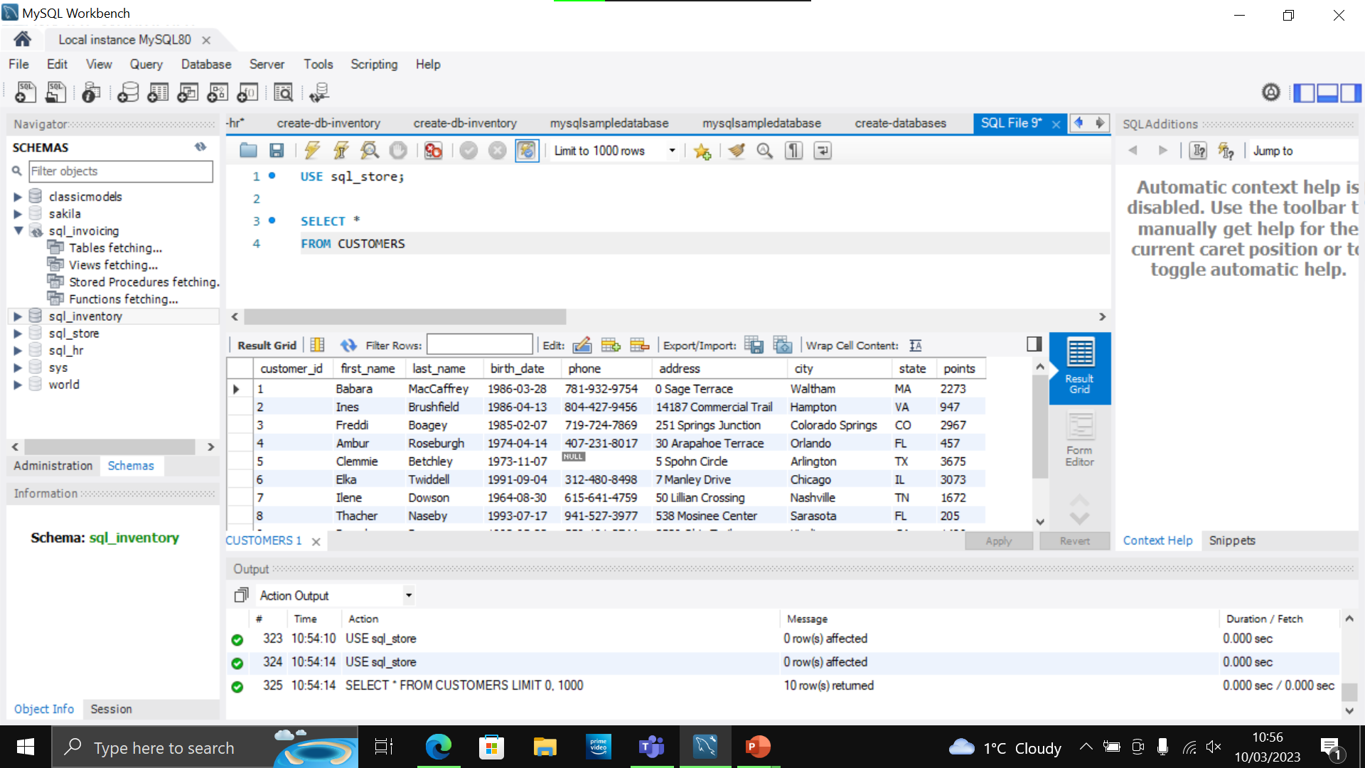

**Query 1 continued**

USE sql_store;

SELECT *

FROM CUSTOMERS

-- WHERE CUSTOMER_ID=1

ORDER BY first_name

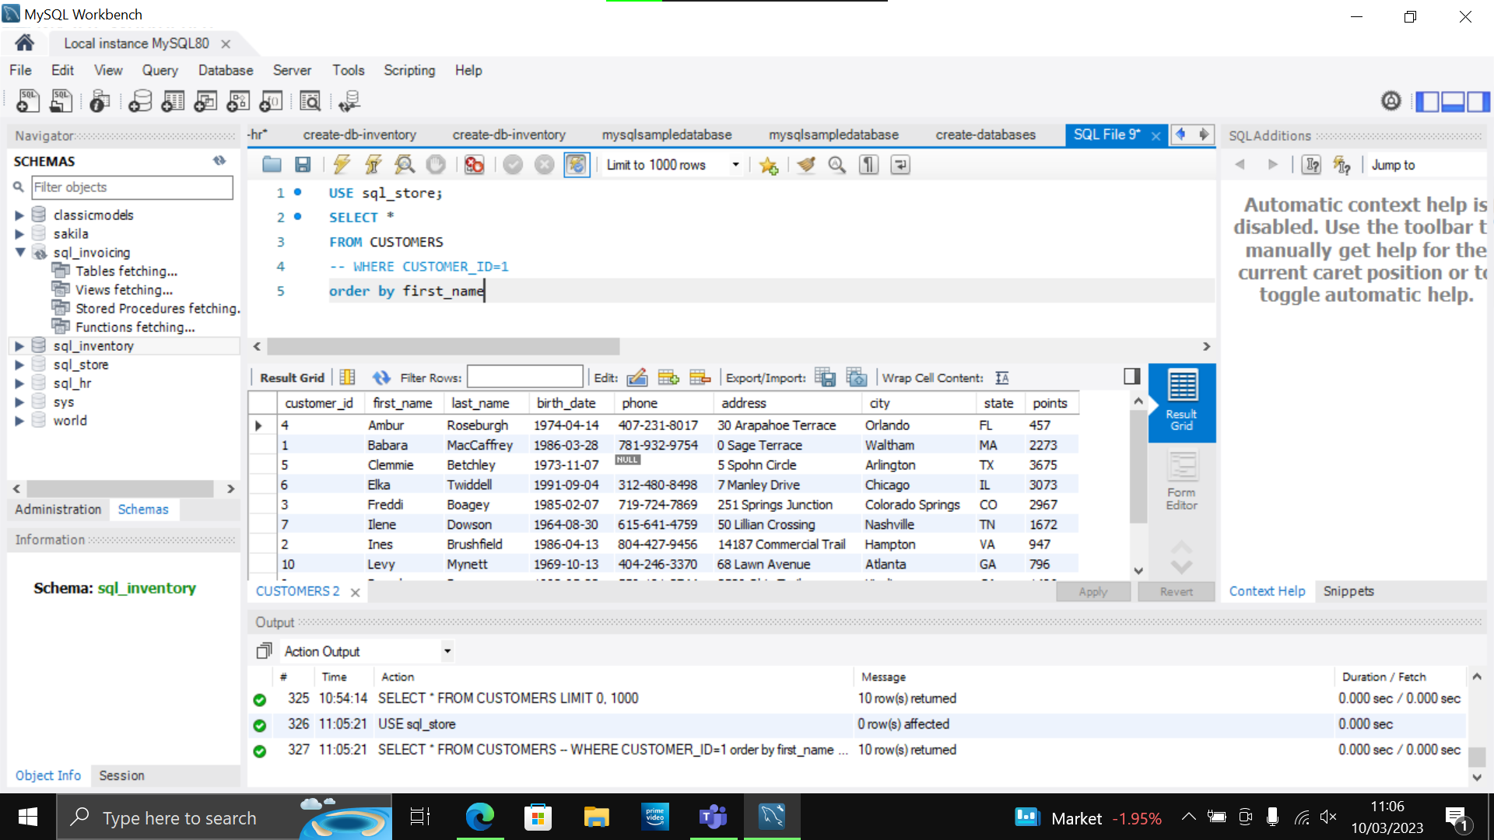

**Query 2 SELECT**

SELECT last_name, first_name, points, points + 10

FROM CUSTOMERS

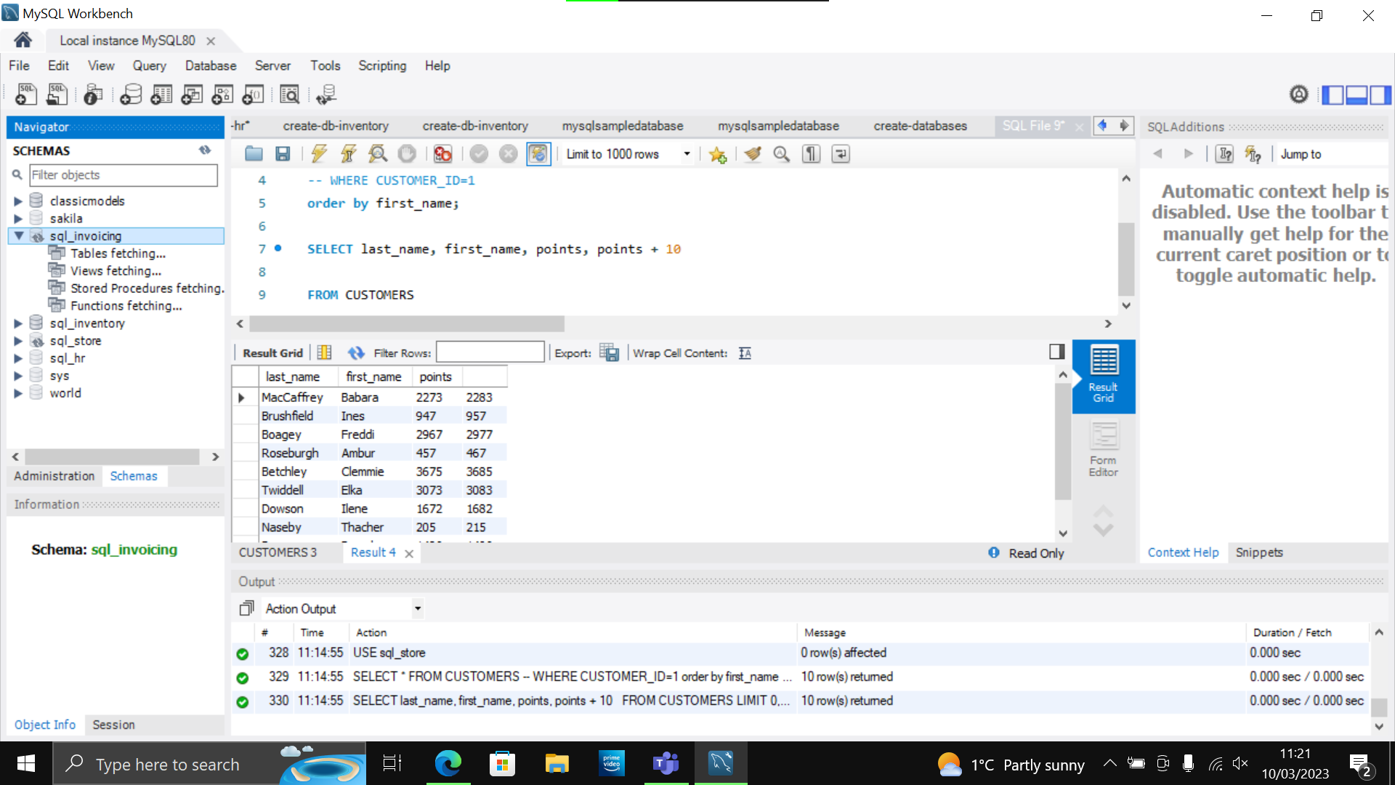

**TASK 1**

* Using the Query 2 you created change the points to reads times by 10 and plus 100. Record your results in your word document
* Change the Query 2 code to create a discount factor so the table now shows a discount header and changing the (points + 10) *100

SELECT last_name, first_name, points, (points + 10) * 100 as Discount_factor

FROM CUSTOMERS

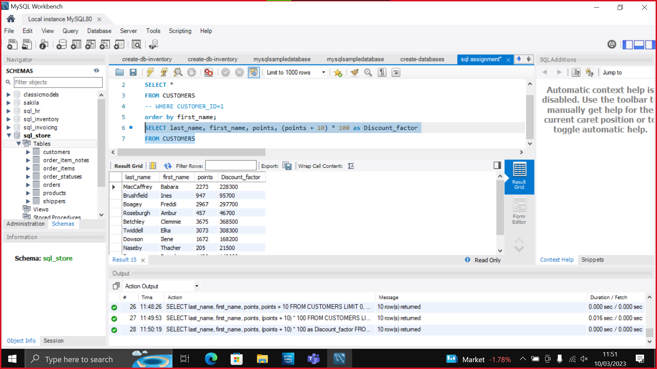

**TASK 2**

* Write a SQL query to return all the products in our database in the result set. I want you to show columns; name, unit price, and new column called new price which is based on this expression, (unit price * 1.1).

So, what you are doing is increasing the product price of each by 10%.

So, with the query we want all the products the original price and the new price.

SELECT name, unit_price, unit_price * 10/100 + unit_price as New_price

FROM products;

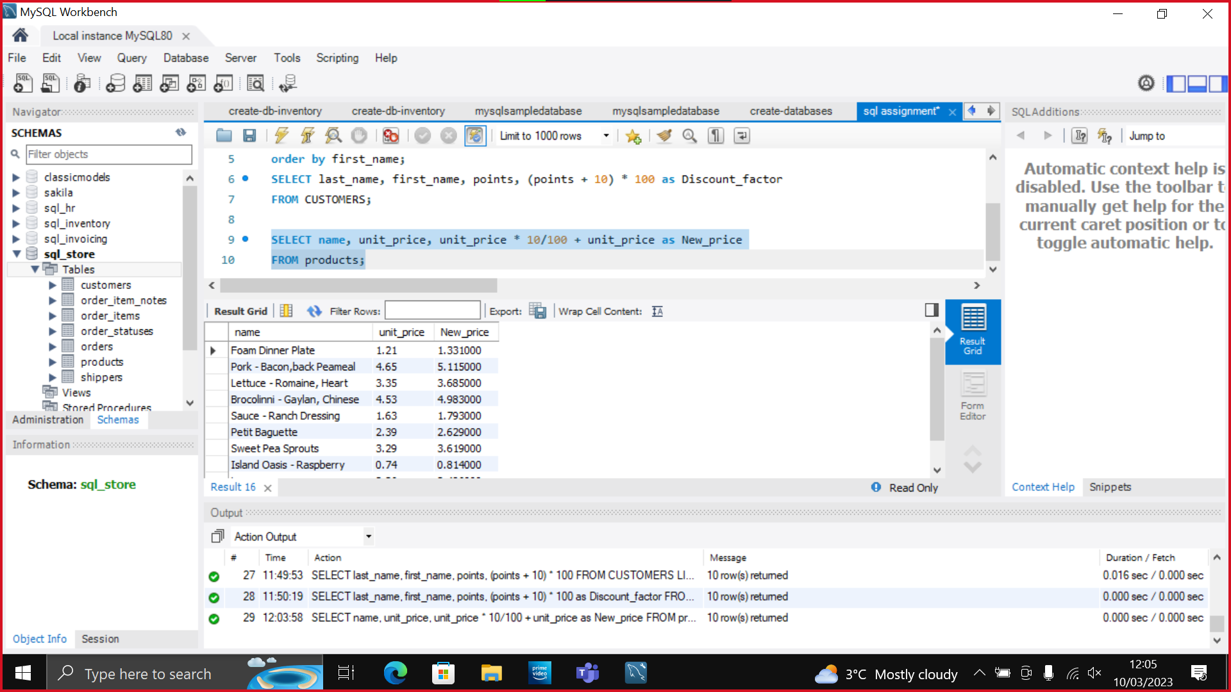

**TASK 3**

In this task create a new query to find all the customers with a birth date of > '1990-01-01'

SELECT first_name, last_name, birth_date

FROM customers

WHERE birth_date > '1990-01-01'

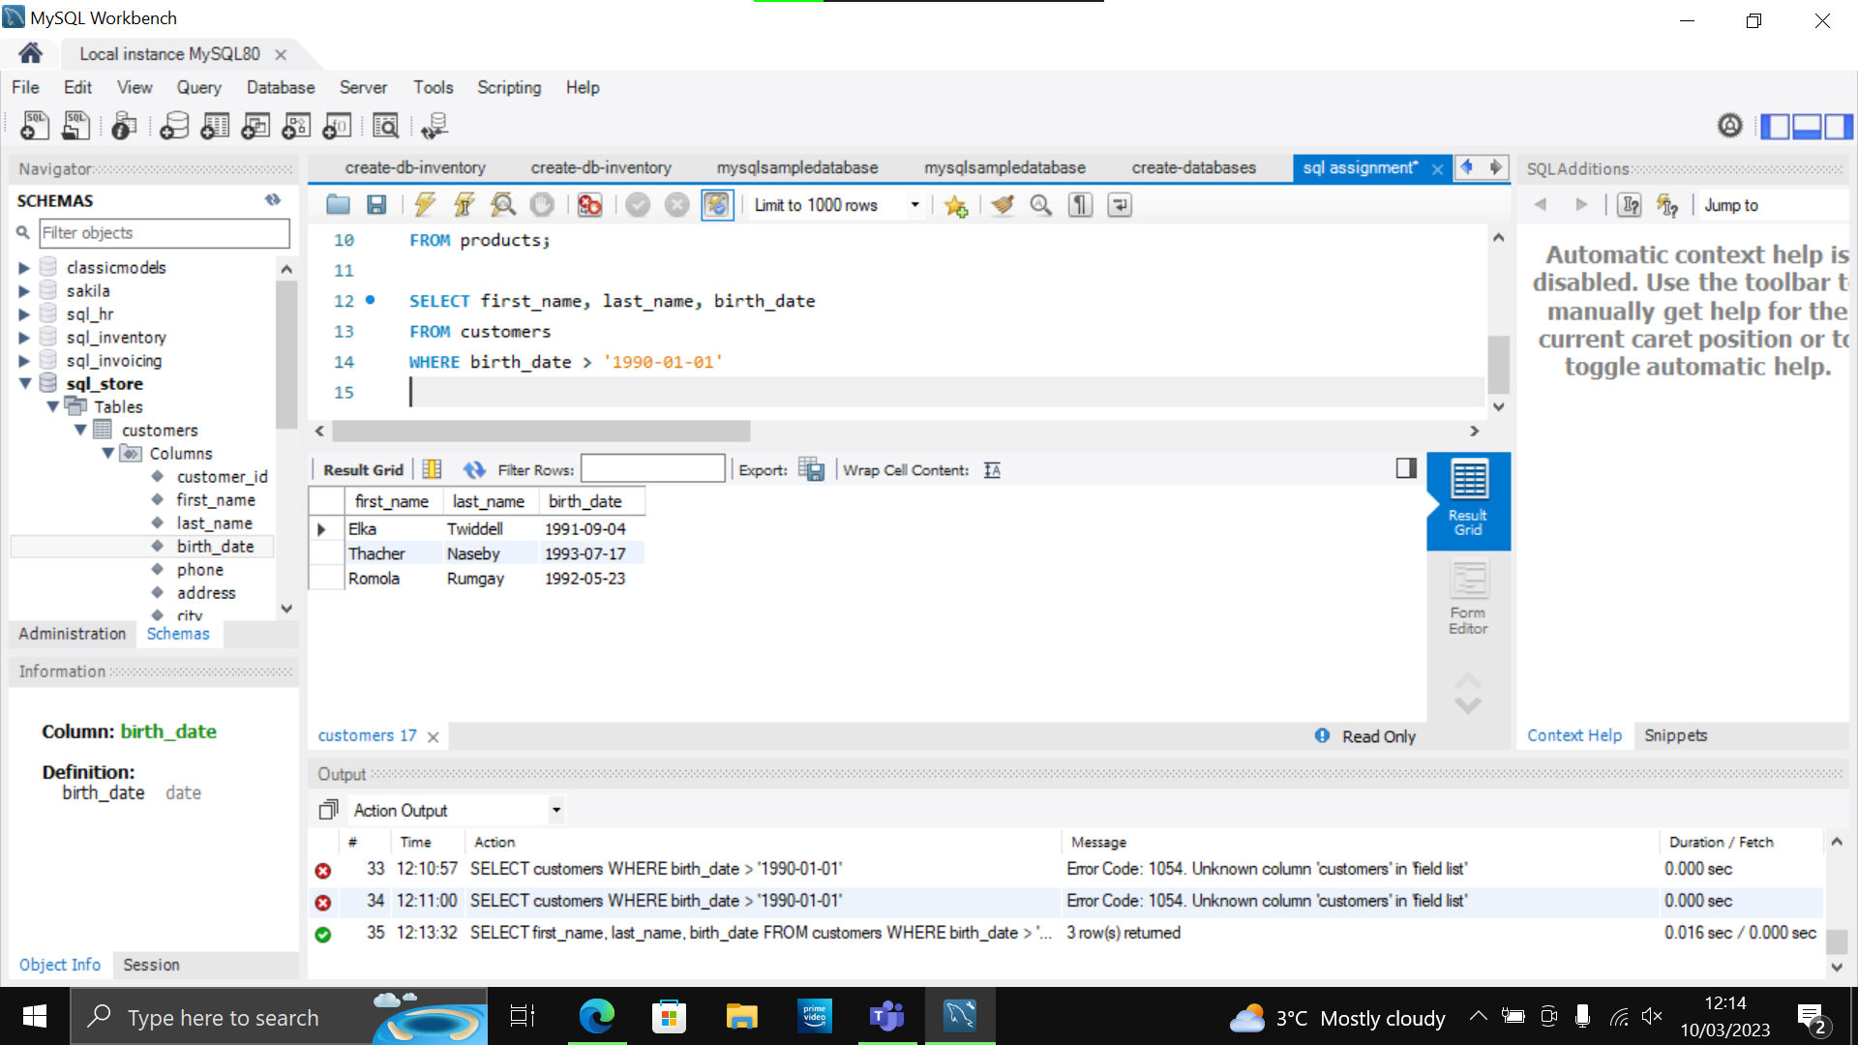

**TASK 4**

Select sql_inventory.

* Write a query to find out the name of the product with most amount in stock.

SELECT name, quantity_in_stock

FROM sql_inventory.products

ORDER BY quantity_in_stock DESC LIMIT 1;

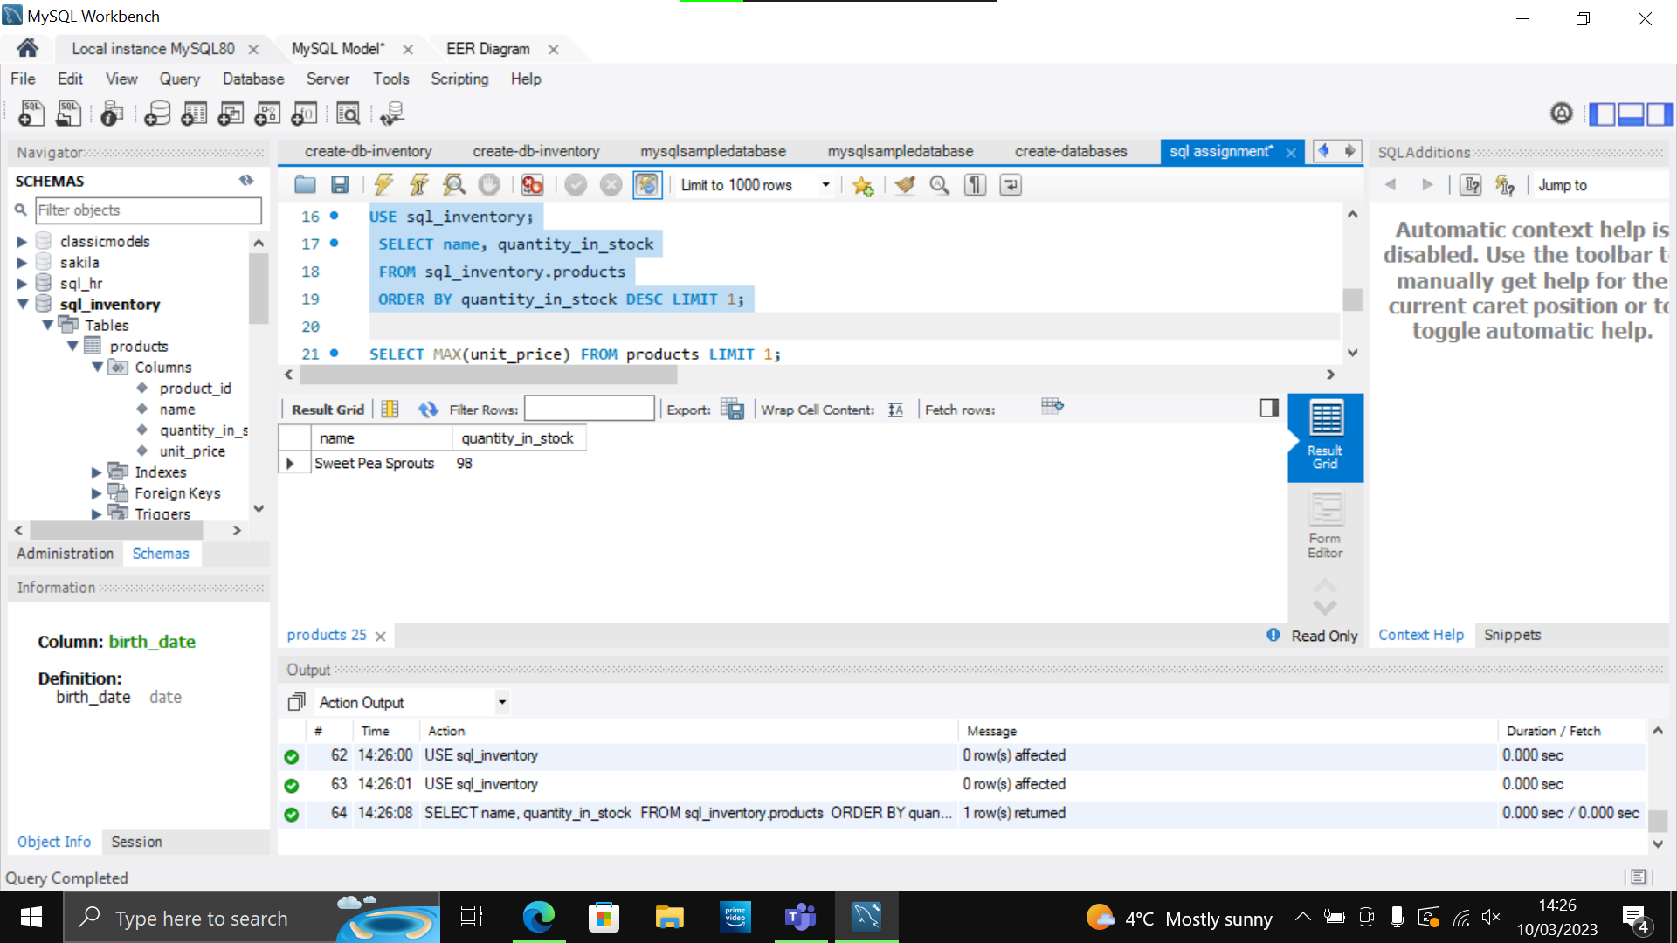

**TASK 5**

* Select sql_inventory.
* Write a query to find out the name of the most expensive product.

SELECT name, unit_price

FROM sql_inventory.products

ORDER BY unit_price DESC

LIMIT 1;

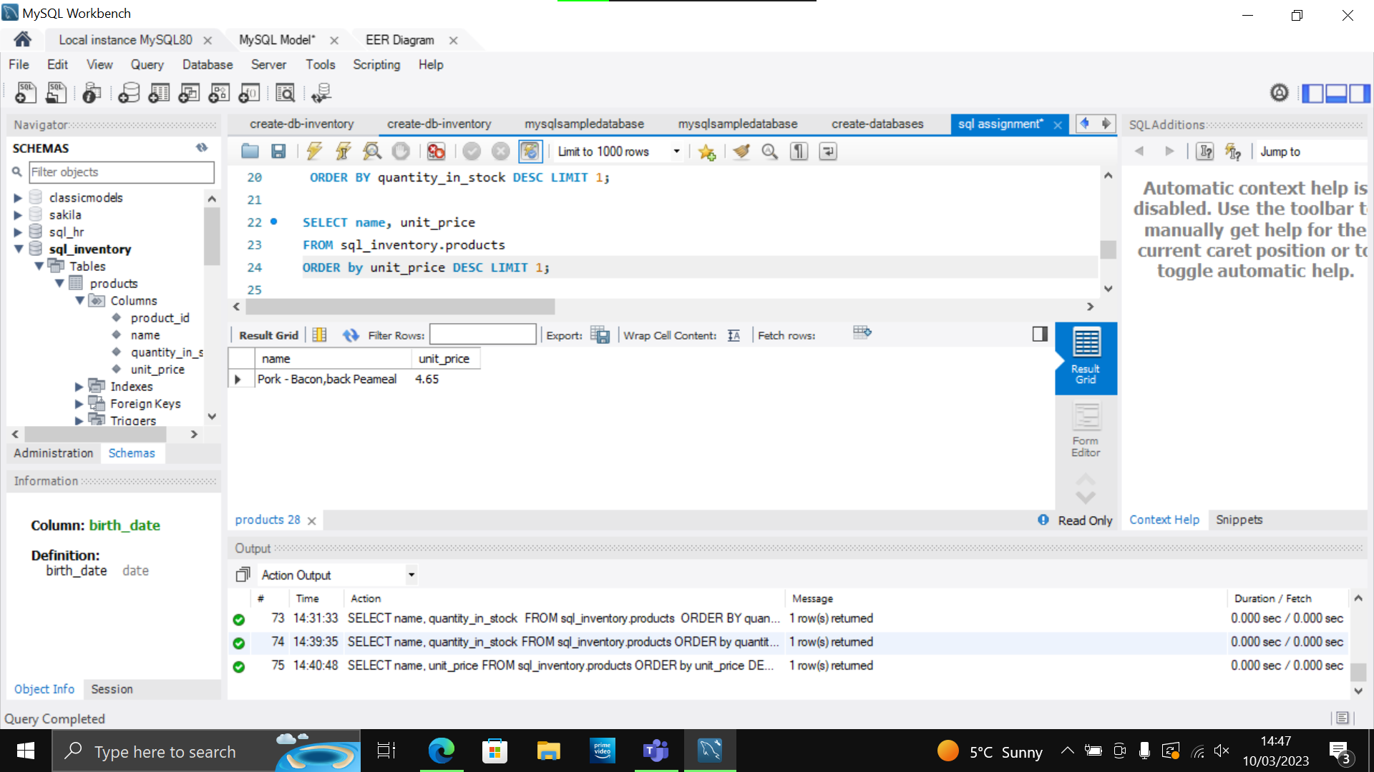

**TASK 6**

* Select sql_store.
* Write a query to find out the first name, last name, address and the birthdate of the oldest customer.

SELECT first_name, last_name, address, birth_date

FROM sql_store.customers

ORDER BY birth_date ASC

LIMIT 1;

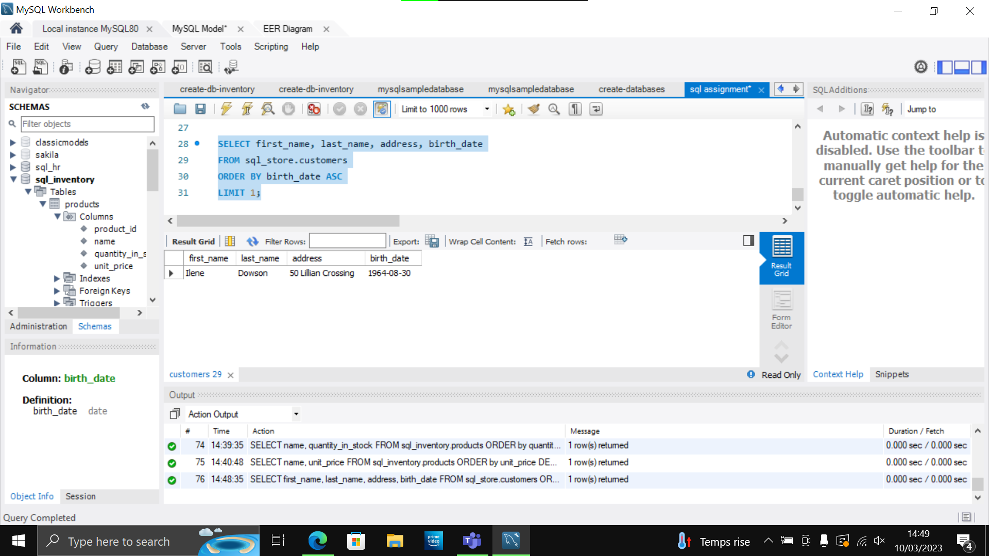

**Reverse Engineer**

